Lab No 6

Question 1
Write a conversion function query to select the name and hire date for all employees from the employee table and display the hire date in the format ‘DD-MON-YYYY HH:MI:SS’ and ‘DD-MON-YYYY’ in two columns, with the TO_CHAR() conversion method.
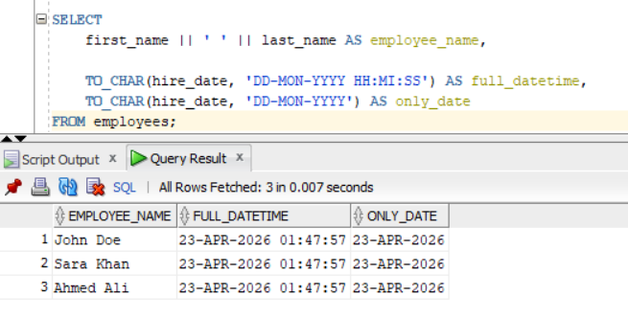

Question 2
Create a query to add an integer and a decimal number (e.g., 100 + 100.1). Explain the output.
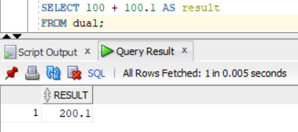
When an integer and a decimal number are added in Oracle, the result is automatically converted into a NUMBER with decimal precision. Oracle performs implicit type conversion and returns the result in the most precise numeric format, which in this case includes the decimal part.
So:
- 100 (integer)
- 100.1 (decimal)
- Result = 200.1 (decimal preserved)

Question 3
Create a query to get and display the employee's full name and salary with the condition:
WHERE salary > '500000'
What happens? Explain the output.
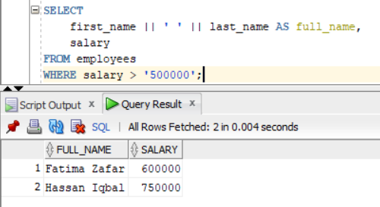
The condition salary > '500000' compares a number with a string. Oracle automatically converts the string into a number, so the comparison works normally. After adding employees with salaries above 500000, those records appear in the result. It is better practice to use numbers instead of strings to avoid implicit conversion.

Question 4
Identify which operand is converted in the following: SELECT * FROM EMP WHERE salary = '500000'; Write two more queries that display applying implicit conversion for the operand values. Further create a query to use an operand value which skips implicit conversion.
The string '500000' is converted into a number because the salary column is numeric. This is called implicit conversion.
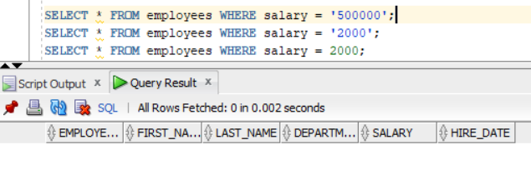
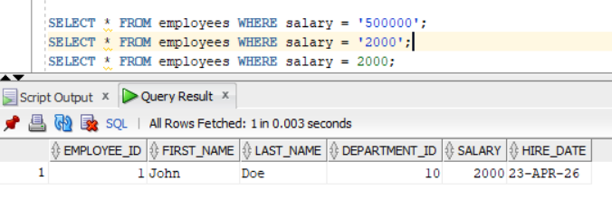
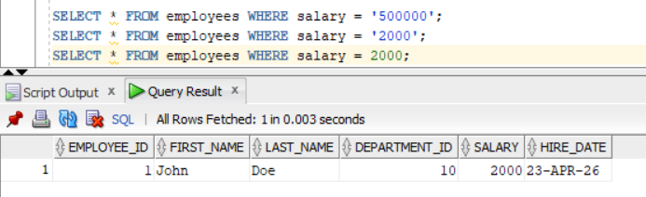
Question 5
Write a query to add 15 days to a date created using TO_DATE().
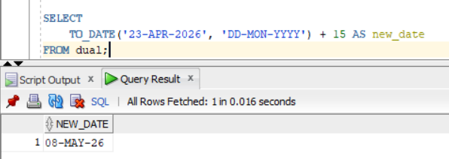
We convert a string into a date using TO_DATE(), then add 15 days. Oracle automatically adds days to dates.

Question 6
Write a query to extract only the date value from a timestamp and display it in the format DD-MON-YYYY.
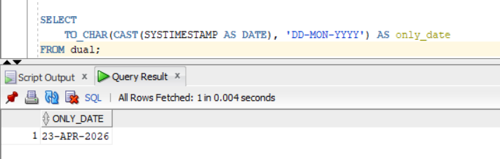
We convert the timestamp into a date using CAST, then use TO_CHAR to display only the date part in DD-MON-YYYY format

Question 7
Display employee names with their hire dates converted to the format
DD-MON-YYYY HH24:MI:SS
and sort the results by hire date (chronologically).
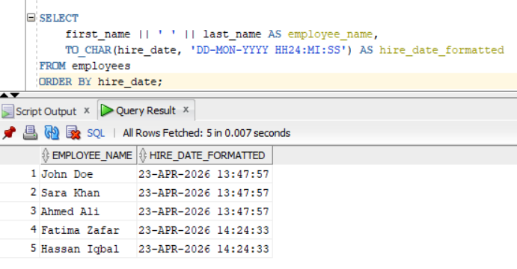
We convert hire_date into a full date-time string using TO_CHAR, then sort the results using the original hire_date column in ascending order.

Question 8
Count the total number of records in SALES for the sales done in the first quarter of 2026.
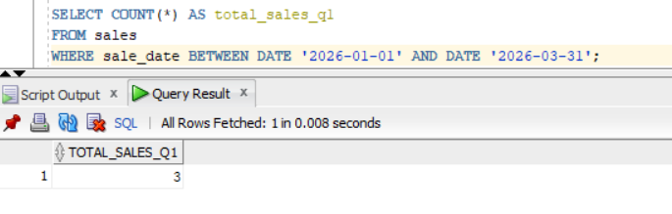
We count all sales that happened between January and March 2026, which represents the first quarter of the year.

Question 9
Write a query to find the total sales amount using SUM().
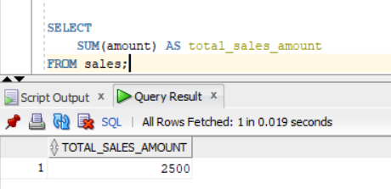
We use SUM() to add all values in the amount column and get the total sales.
Question 10
Write a query to count the number of sales in each region and display the results from the highest to least value of total_sales.
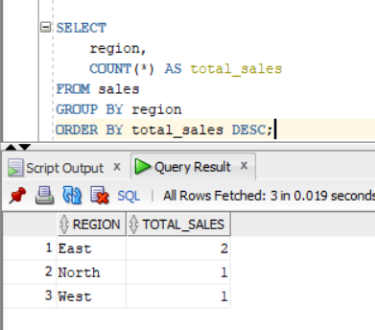
We group sales by region, count how many sales happened in each region, and then sort them from highest to lowest.

